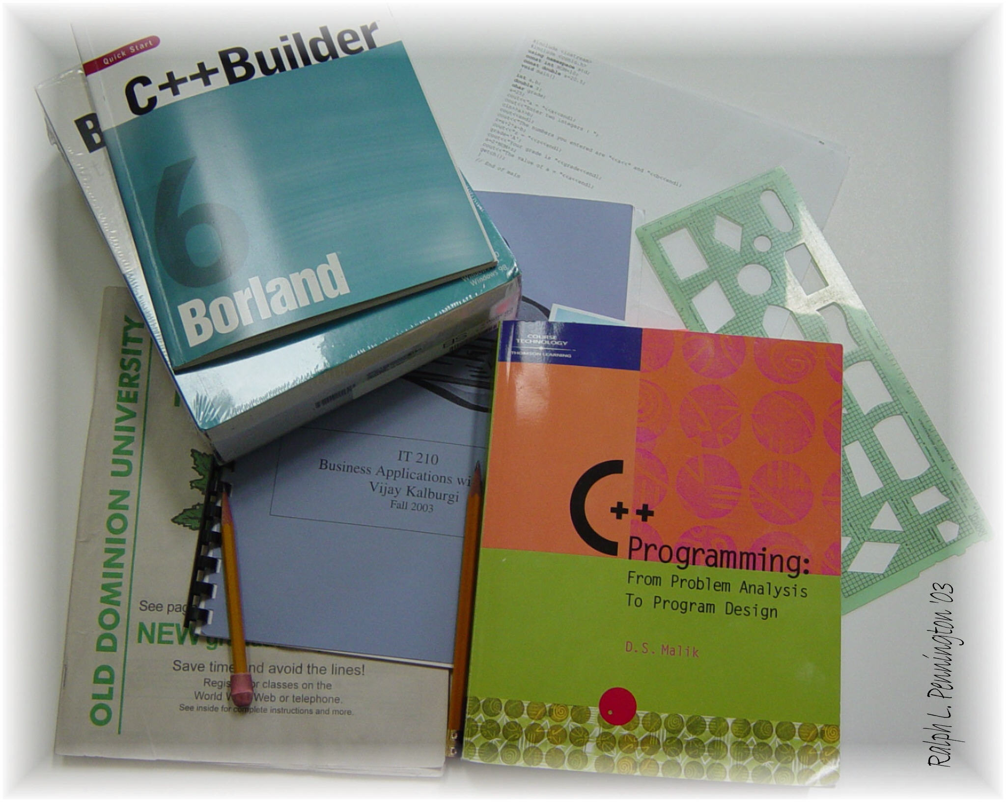

Michael Ragsdale
IT210 Business Applications with C++
TR 11:00 – 12:15 PM
Instructor: Vijay Kalburgi

Program Assignment 3

Credit Card Record System
Fall 2014

Michael Ragsdale

00978282

Credit Card Record System

October 9, 2014

